| Course Name | ITD 2313 – Script Programming |
| --- | --- |
| Instructor | Mark Pranger |
| Student Name | Weston Albright |
| Due date | 06/03/2025 |
| Grade | 97.34% |
| Grading Comments | N/A |

Modify the guessing-game program of Section 3.5 in the file guess.py so that the user thinks of a number that the computer must guess. The computer must make no more than the minimum number of guesses, and it must prevent the user from cheating by entering misleading hints. (Hint: Use the math.log function to compute the minimum number of guesses needed after the lower and upper bounds are entered.)

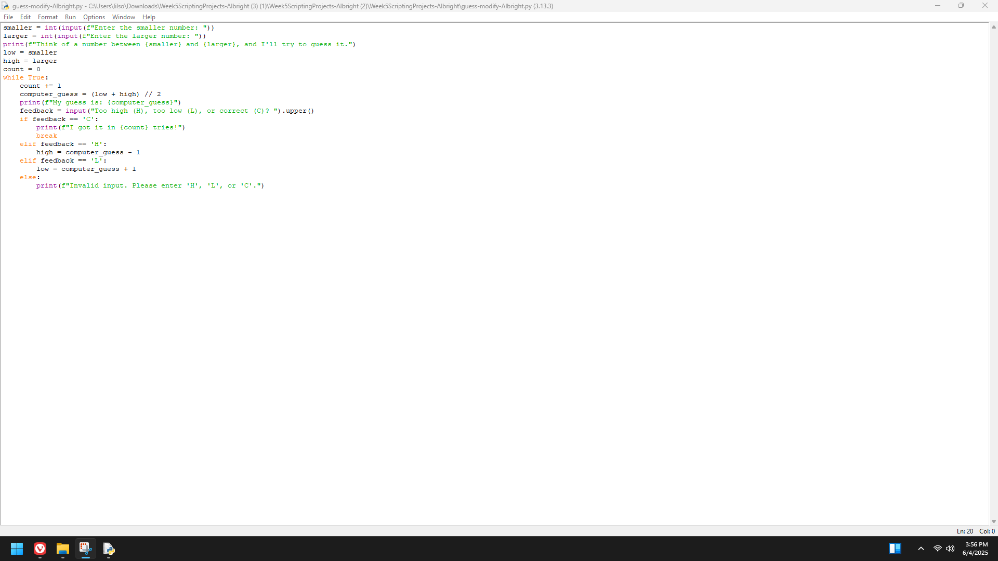

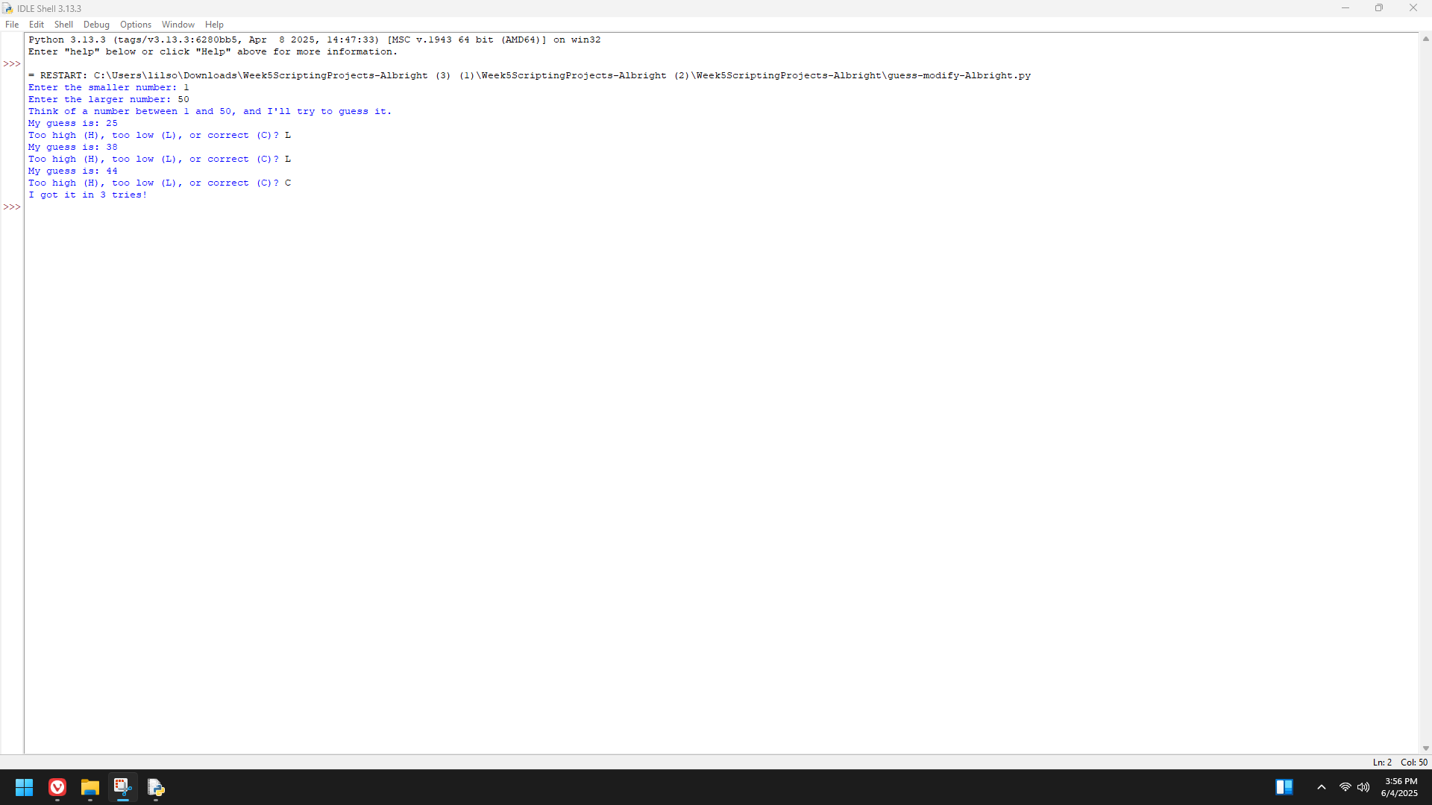

Teachers in most school districts are paid on a schedule that provides a salary based on their number of years of teaching experience. For example, a beginning teacher in the Lexington School District might be paid $30,000 the first year. For each year of experience after this first year, up to 10 years, the teacher receives a 2% increase over the preceding value. Write a program in the file salary.py that displays a salary schedule, in tabular format, for teachers in a school district. The inputs are the starting salary, the percentage increase, and the number of years in the schedule. Each row in the schedule should contain the year number and the salary for that year

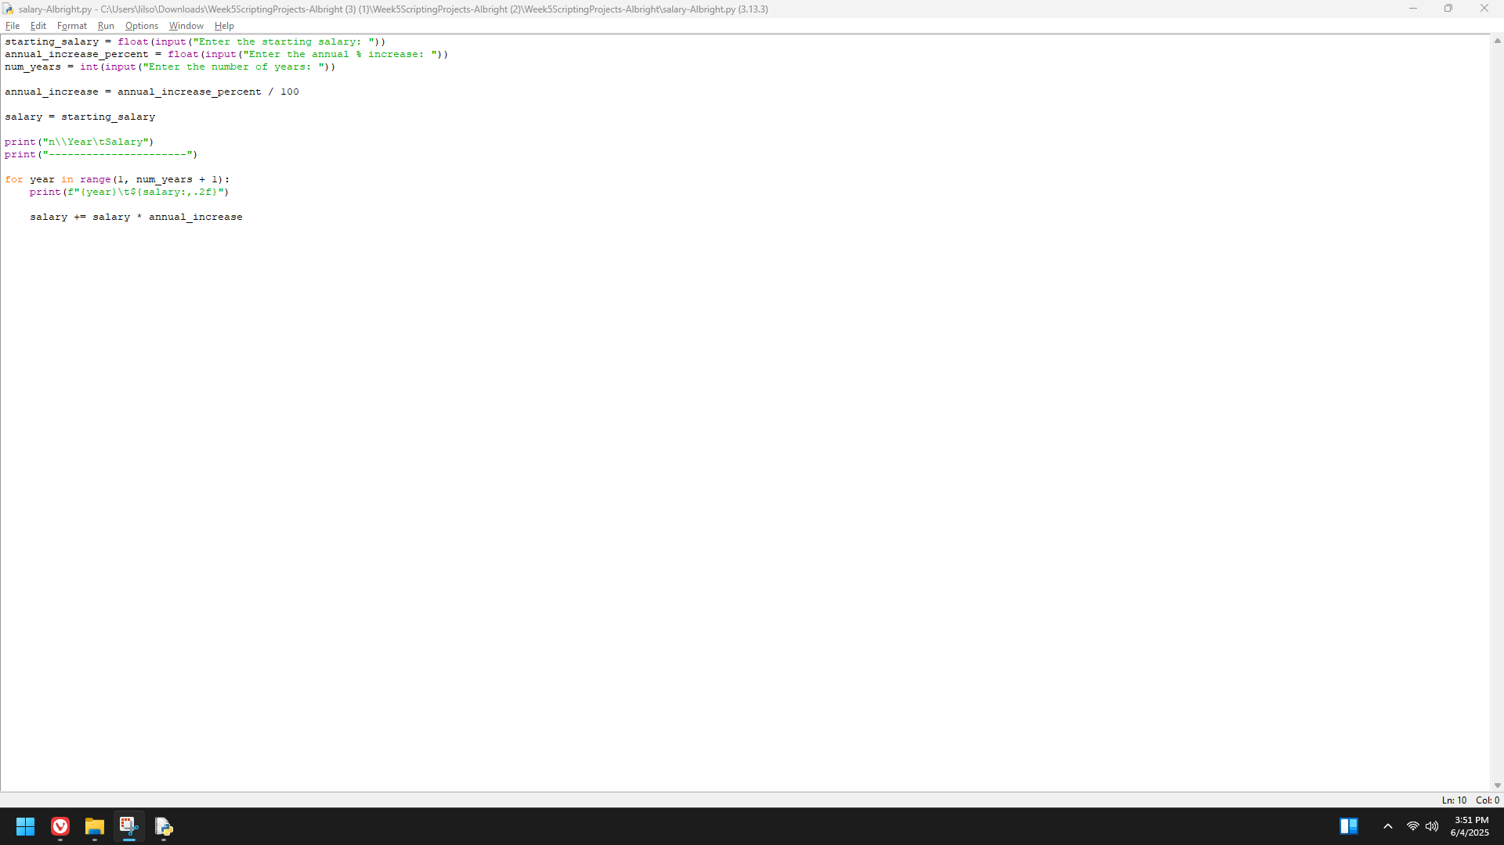

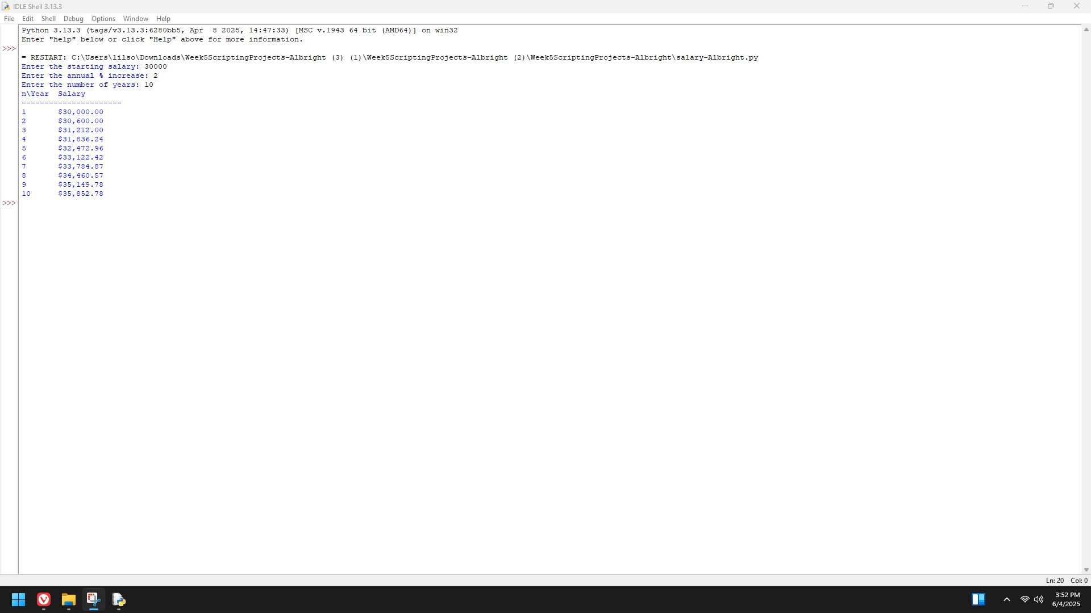

The credit plan at TidBit Computer Store specifies a 10% down payment and an annual interest rate of 12%. Monthly payments are 5% of the listed purchase price, minus the down payment. Write a program in the file tidbit.py that takes the purchase price as input. The program should display a table, with appropriate headers, of a payment schedule for the lifetime of the loan. Each row of the table should contain the following items:

the month number (beginning with 1)

the current total balance owed

the interest owed for that month

the amount of principal owed for that month

the payment for that month

the balance remaining after payment

The amount of interest for a month is equal to balance * rate / 12. The amount of principal for a month is equal to the monthly payment minus the interest owed.

